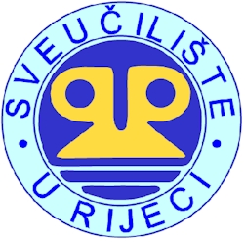
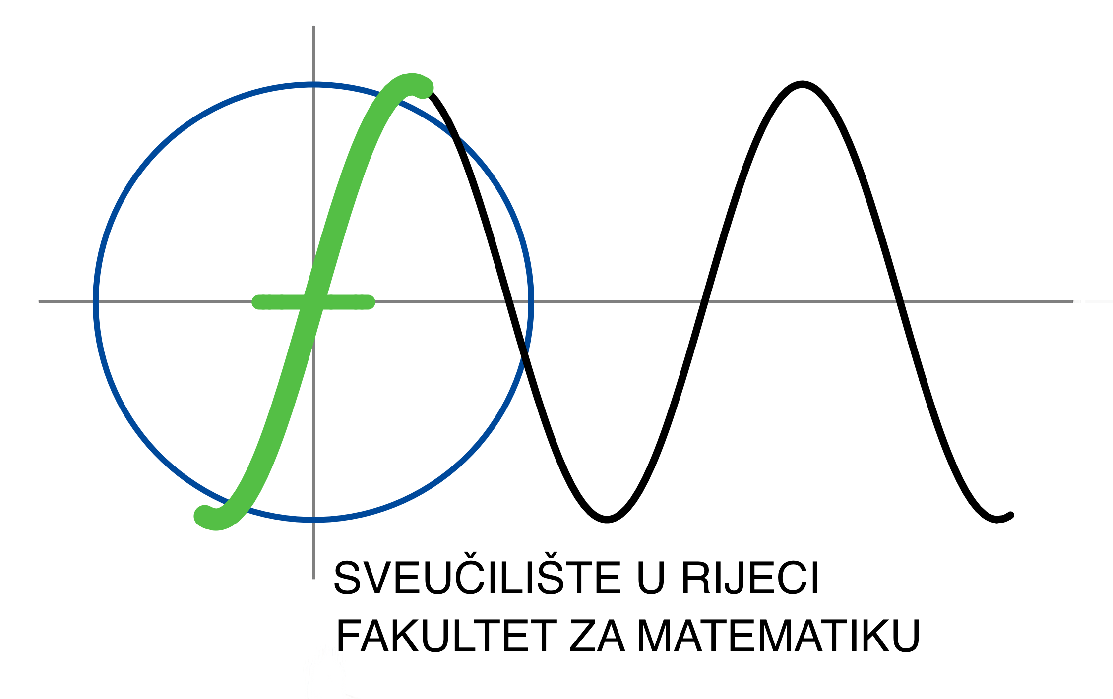

ERASMUS STAFF TRAINING MOBILITY/WORK PROGRAMME
(to be filled out by teaching, administrative and technical staff who apply for mobility with the intent of professional training)

Name of staff member
Name of home institution
(Erasmus ID code)
Contact person at home institution
(Head of department/office/institute or dean of faculty)
Position of contact person at home institution
Office/department/unit

Name of host institution | Faculty of Mathematics, University of Rijeka, Croatia
Erasmus code - if the training will be held at HE institution | HR RIJEKA01
Duration of mobility (min. 2 days, max. 2 months, days spent on travel do not count)
Agreed time of mobility
(dates)
Name of contact person at host institution | izv.prof.dr.sc Vera Tonić
Position of contact person at host institution | Academic Erasmus coordinator for the Faculty of Mathematics, University of Rijeka

Office/department/unit at host institution within which the candidate will do their training |  | Faculty of Mathematics, University of Rijeka
Size of the host institution/enterprise:  Small: 1-50 staff; medium: 51-500 staff; large: 501 or more staff |  | large
VAT number of host institution (if host institution does not have Erasmus charter)
Sector (type of host institution) |  | University
Field/subject of training |  | Mathematics
Activities to be carried out and, if possible, the programme for the period  (add number of days according to duration of mobility) | Day 1
 | Day 2
 | Day 3
 | Day 4
 | Day 5
Objectives and added value of the mobility for the home institution
Objectives and added value of the mobility for the staff member

*In choosing grant recipients, the correlation between the duration of stay at the foreign institution and the working and teaching load will be taken into account.

Date: dd/mm/20xx

Applicant’s signature: _________________

Signature of contact person at the host institution:
(Confirming the candidate’s work programme)

